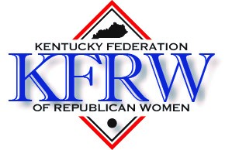

Kentucky Federation of Republican Women
2025 Scholarship Program

The Kentucky Federation of Republican Women grants a $1,500.00 scholarship to a college-bound high school senior girl who has been politically active within the Republican Party. The qualified applicant will graduate from a Kentucky high school in 2025, is or will be a registered Republican, and plans to enroll at an accredited college or university in Kentucky.
The complete application will include the following:
- Completed application form
- A one-page typed essay about a Republican woman you admire or who has influenced your life and why
- An official copy of your high school transcript, which may be mailed separately
- Two letters of recommendation
The completed application must be mailed with a postmark no later than Monday. March 31, 2025, to:
Patty Harman
KFRW Scholarship Chair
134 Paul Revere Drive
Georgetown, KY 40324

KFRW Scholarship Application Form
Name:

Street address:

City: | State: | ZIP:
Phone: | Email address:
Proposed college or university:

Please give a summary of your political activities within the Republican Party. If more space is needed, please attach additional information. (Please keep in mind that becoming a registered voter is not a political activity. School club activity should not be included in this section. Please include school club activity in your list of high school activities.)

Summary of community and/or church activities: (If more space is needed, please attach additional information).

High School Information
Name of High School:

Street address:

City: | State: | ZIP:
Anticipated graduation date: | Cumulative Grade Point Average:
Summary of high school activities and achievements: (If more space is needed, please attach additional information)

I verify that the information in this application is true and accurate to the best of my knowledge.

Signature of applicant: Date

