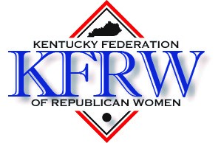

Kentucky Federation of Republican Women
2024 Scholarship Program

The Kentucky Federation of Republican Women grants a $1,500.00 scholarship to a college-bound high school senior girl who has been politically active within the Republican Party. The qualified applicant will graduate from a Kentucky high school in 2024, is or will be a registered Republican, and plans to enroll at an accredited college or university in Kentucky.
The complete application will include the following:
- Completed application form
- A one-page typed essay about a Republican woman you admire or who has influenced your life and why
- An official copy of your high school transcript, which may be mailed separately
- Two letters of recommendation
The completed application must be mailed with a postmark no later than Wednesday, April 3, 2024, to:
Patty Harman
KFRW Scholarship Chair
134 Paul Revere Drive
Georgetown, KY 40324

KFRW Scholarship Application Form
Name:

Street address:

City: | State: | ZIP:
Phone: | Email address:
Proposed college or university:

Please give a summary of your political activities within the Republican Party. If more space is needed, please attach additional information. (Please keep in mind that becoming a registered voter is not political activity. School club activity should not be included in this section. Please include school club activity in your list of high school activities.)

Summary of community and/or church activities: (If more space is needed, please attach additional information).

High School Information
Name of High School:

Street address:

City: | State: | ZIP:
Anticipated graduation date: | Cumulative Grade Point Average:
Summary of high school activities and achievements: (If more space is needed, please attach additional information)

I verify that the information in this application is true and accurate to the best of my knowledge.

Signature of applicant: Date

