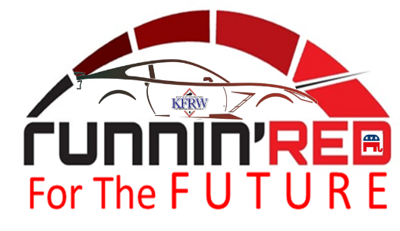
KENTUCKY FEDERATION OF REPUBLICAN WOMEN
BIENNIAL CONVENTION
HOLIDAY INN SLOAN CONVENTION CENTER BOWLING GREEN KY

SEPTEMBER 9 – 10, 2022

WOULD YOU LIKE TO SPONSOR A TABLE AT OUR KFRW BIENNIAL CONVENTION?

THE COST TO SPONSOR A TABLE IS $500. TABLE SPONSORSHIP CAN BE PURCHASED FOR THE LUNCHEON ON SATURDAY OR THE BANQUET ON SATURDAY NIGHT. IT WILL INCLUDE 2 SEATS WITH PREMIERE SEATING AND RECOGNITION IN OUR CONVENTNION PROGRAM.

SPECIAL GUEST FOR LUNCH ON SATURDAY:

NFRW PRESDIENT – EILEEN SOBJACK

SPECIAL GUESTS FOR DINNER ON SATURDAY:

SENATOR AND MRS. RAND PAUL (R – KY)
SENATOR MARSHA BLACKBURN (R-TN)

FULL CONVENTION REGISTRATION INCLUDES HEAVY APPETIZERS ON FRIDAY EVENING AND THE LUNCHEON, BREAKOUT SESSIONS AND DINNER ON SATURDAY. SIGNAGE WITH YOUR NAME AS A SPONSOR WILL BE PLACED ON TABLES AT EITHER EVENT. PLEASE SUBMIT THE NAMES OF GUESTS WHO WILL SIT AT YOUR TABLE BY THE DEADLINE OF AUGUST 20, 2022.

__________YES, I WILL SPONSOR A TABLE FOR THE LUNCHEON ON SATURDAY

__________YES, I WILL SPONSOR A TABLE FOR THE DINNER ON SATURDAY

__________NO, I CAN NOT SPONSOR A TABLE AT EITHER EVENT BUT WILL GIVE A

DONATION IN THE AMOUNT OF __________

PLEASE MAKE CHECKS PAYABLE TO THE KFRW AND MAIL TO:
CAROL ROGERS
2417 WILLIAMSBURG ESTATES LANE - LEXINGTON, KY 40504

DEADLINE FOR SPONSORSHIP IS AUGUST 20, 2022.

