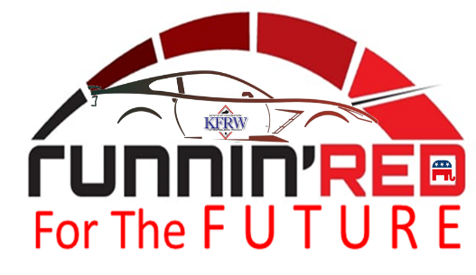
KENTUCKY FEDERATION OF REPUBLICAN WOMEN
BIENNIAL CONVENTION
HOLIDAY INN SLOAN CONVENTION CENTER BOWLING GREEN KY

SEPTEMBER 9 – 10, 2022

FRIDAY - SEPTEMBER 9

12 – 2 PM
LUNCHEON / FASHION SHOW FOR LLC MEMBERS

3 – 6 PM
REGISTRATION OPEN

3:30 - 4:30 PM
RECEPTION WITH 2021 & 2022 CLUB PRESIDENTS & NFRW PRESIDENT

5 – 6 PM
EXECUTIVE COMMITTEE MEETING

6 – 7:30 PM
OPENING NIGHT RECEPTION - REPUBLICAN CANDIDATES INVITED

8:00 – 9 PM
ENTERTAINMENT - TREVOR MARTIN – COUNTRY MUSIC ARTIST

SATURDAY - SEPTEMBER 10

8:30 – 11:00 AM
KFRW CONVENTION BUSINESS
ELECTION OF 2023-2024 KFRW OFFICERS

11:30 AM – 1 PM
LUNCHEON
NFRW President - Eileen Sobjack

1:30 – 4:30 PM
WORKSHOPS/SESSIONS
Topics of Discussion – Voter Integrity, Social Media & Technology, Legislative Platform

6:00 –7:00 PM
PRIVATE RECEPTION FOR LLC MEMBERS

7:00 – 9:00
DINNER AND LIVE AUCTION

