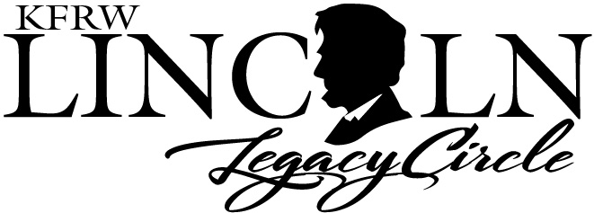

KFRW Members:

It is join/renewal time for the “Lincoln Legacy Circle”! The LLC replaces the former “First Lady’s Circle”. We feel that the “Lincoln Legacy Circle” better describes our mission and commitment to the legacy of Abraham Lincoln and the Republican Party.

The KFRW “circle” has an annual membership fee of $100.00.

It will offer the following to its members:

1. A platform to “honor” the legacy of Lincoln and the GOP.
2. Increase KFRW member awareness of our overall political efforts.
3. The Lincoln Legacy Circle will sponsor special event(s) annually and honor all members at KFRW functions.

Our membership continues to grow as does our donations to candidates. The cumulative donation total for the past years has reached over $40,000.00.

We fund our candidates using this formula:

Highest % Donation KFRW Members (women)

2nd Highest % Donation KFRW Associate Members (men)

3rd Highest % Donation Women Candidates

4th Highest % Donation Men Candidates

You can join LLC at any time throughout the year, but I encourage you to join early so that you may participate in the annual “thank you” event. A membership application is attached to this email. Please submit your renewal dues to LLC Chair, Julie Hinson, and make the check out to KFRW Lincoln Legacy Circle. Please continue to support this “circle” no matter the name.

Sincerely,

Julie Harris Hinson, Lincoln Legacy Circle Committee Chair

Note: Membership is an annual fee and entitles the member to attend a planned special event as well as be included in all activities related to the Lincoln Legacy Circle. Your annual fee provides additional support to our candidates and promotes KFRW.



MEMBERSHIP APPLICATION 2021

Name:_______________________________________________________________________

Club:________________________________________________________________________

Contact Information:

Email:_______________________________________________________________________

Phone:______________________________________________________________________

Address: ____________________________________________________________________

Submit: $100.00

Julie Hinson, LLC Chair

5604 Wolf Pen Trace

Prospect, KY 40059

Make check payable to: KFRW Lincoln Legacy Circle

Note: Membership is an annual fee and entitles the member to attend a planned special event as well as be included in all activities related to the Lincoln Legacy Circle. Your annual fee provides additional support to our candidates and promotes KFRW.