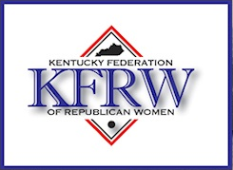

Hello:

It is time again to renew your membership in your local club, the Kentucky Federation of Republican Women (KFRW), and the National Federation of Republican Women (NFRW). Your membership will be a part of the most active and influential Republican Women’s group in Kentucky and the nation.

The KFRW and your club are committed to increase Republican women’s membership rolls this year, bringing us to over 1,000 members. With our Republican Governor, Lieutenant Governor, Treasurer, and State Auditor, we welcome your continued support.

We did “ FLIP THE HOUSE” ! Thank you for all your efforts to accomplish this feat! Now we can really get busy getting new members and helping to keep all we have done. We need your vote and your participation.

With your membership comes not only genuine camaraderie with your club members, but also opportunities to meet and work with dedicated Republican women from across the state. You will have access to the NFRW web site by going to:

http://www.nfrw.org/user/login and follow the directions

Sign up for NFRW emails: https://www.nfrw.org/email You will need to login to the NFRW Member Center page to access this page

Sign up for information from the KFRW: http://www.kentuckyrepublicanwomen.org

Let's get a good start to 2018. Won’t you please remit your 2018 membership dues to your club and join the over 790 members of 2017 and help us boost our numbers to over 1,000 in 2018.

Sincerely,

Debby Neal Pate
Membership Vice President, KFRW
(502) 552-8179

